**A. FET**  
**Butterfly.**

Are you familiar with the word “outline”?.. I will give you a visual explanation of it.

I put my hand on top of the piece of parer and trace it or outline it with a marker.

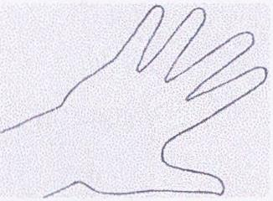

We got a picture which is …what? (Outline of the hand.)

Let’s look at the picture below.

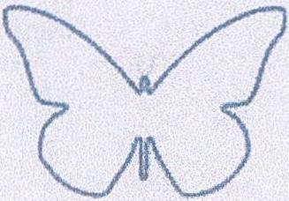

What do you see on this picture? Whose outline it is showing? (Outline of a butterfly.)

Is the outline of the butterfly beautiful? Do you like it?

There is one more picture, that has an outline of a butterfly that is filled with color.

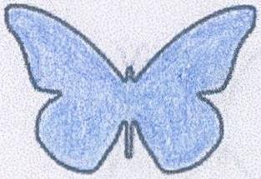

On the firsе image the outline was not filled in with color, kind of like airy outline. Which one of the two images looks more beautiful?

But uncolored, “airy” outline of a butterfly is also very beautiful. Don’t you think so?

I didn’t bring the images of a butterfly to your attention by accident. Can you guess what this poem is going to be about?

- 2 -

There is a fragment in the poem:

With just an airy outline I am so cute.

Have you ever seen butterflies soaring over the flowers? Did they capture your attention? Did they make you curious? Did you chase them, trying to catch them?

Butterflies are some of the most beautiful insects on the planet. There are a lot of them soaring above meadows over the flowers and they themselves are like live flowers. The image of butterflies soaring over the meadows won’t leave anyone indifferent.

So the poet Afanásiy Fet also could not stay indifferent. And he dedicated one of his poems to them. The beginning of the poem is unusual:

You are right.

The poem starts with this short sentence.

The fraises “you are right”, “you are not right” are very familiar to you. You have heard and used them yourselves in different situations. Here it means “you are not mistaken, your thinking is correct”.

Please read the poem in prose translation from the Russian poem about a butterfly by Afanasiy Fet. It is called just that “Butterfly”.

You are right. With just an airy outline  
I am so cute.  
All my velvet with it’s lively blinking  
is only two wings.  
  
Don’t ask where I came from  
and where I am hurrying.  
Here on the light flower I descended  
and now I breathe.  
  
How long without purpose and effort  
will I breathe?

- 3 -

And now I will spark by spreading my wings  
and fly away.

Did you like the poem? Did you like the butterfly? Let's read it again and think through the first stanza. The poem’s hidden mysteries are opening up to us in it.

**You are right. With just an airy outline**  
**I am so cute.**  
**All my velvet with it’s lively blinking**  
**is only two wings.**

Which picture would you draw based on these sentences? What would you depict on it?.. A butterfly?..

Does not it feels like someone else is present near the butterfly? Let's not forget the beginning of the first stanza, the words “**you are right**”.

The butterfly is not alone, someone is there near it. That someone needs to be painted too. Who is it in your opinion: a little animal? an insect?

Maybe it is a person? For example, one of the passersby stands and watches her. Maybe he moved closer to see her better, admiring her?

So, what will we draw? (*Butterfly and a person leaning over her.*)

Now while reading the poem we are seeing a person next to the butterfly. And in this case, we can easily imagine ourselves standing next to the butterfly. And we, ourselves, can experience the impression that the butterfly made on that person.

It is easy for the author to see himself in place of the person. It is not “somebody” or “someone”, - the portrait of this person is in front of you.

This poet, Afanasiy Fet shared with us his impressions of a butterfly.

- 4 -

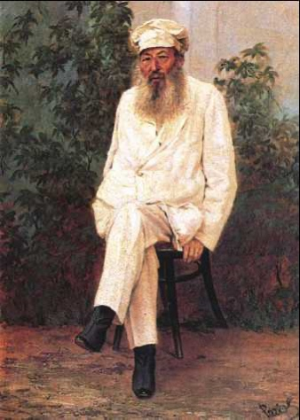

*The portrait of A. Fet, 1880s years. The painter N. Rachkov.*

~~~~~~

Let's go back to the beginning of the first stanza:

**You are right.**

And now here is the question that may seem funny and simple to you: who is saying that and to whom?

Do you think the butterfly is saying that?

The person who is watching her is saying that.

He is saying it to himself. He is not saying it out loud, but inside his head, in his mind. These are his thoughts. All of the poem - is a collection of thoughts of a person, who we imagine is standing next to the butterfly. The whole text of the poem are thoughts out loud.

~~~~~~

You could ask: why is he speaking for the butterfly?

It is not so easy to explain. I will give you two examples.

When a very little baby crying, baby’s mother often talks for him. For example: “I’m hungry, I want porridge!” Hurry up and feed me, mom!” - she says, preparing porridge. Or: “My tummy is hurting, I don’t feel well!” - she is saying while rubbing the baby’s belly.

- 5 -

You can say: Why is it important, who is talking? What is the difference?

The difference is as such:

In one case we learn about the butterfly’s beauty through her own self enjoyment. And in the second case, we learn about its beauty through the delight of a person observing this beauty. His joy is easy to understand, it captures us, we feel it along with him.

~~~~~~

Now let's re-read and think through the poem.

**You are right. With just an airy outline**  
**I am so cute.**

How do we picture a butterfly: with closed or open wings?

Usually we think about a butterfly in words like: beautiful, splendid, lovely. What dose the person, who is watching her, think about her? (*So cute.*)

Is only the butterfly’s outline beautiful? Let's read the next two sentences.

**All my velvet with it’s lively blinking**  
**is only two wings.**

As we see, the butterfly is made lovely not only by its outline.

How much velvet does the butterfly have? - read. (*All my velvet - is only two wings.*) Does the butterfly have a lot of velvet? (*Little*). If someone’s outline itself is beautiful, they don’t even a lot of velvet to enhance the beauty.

What else the poet say about the butterfly’s “velvet”? (*With it’s lively blinking.*)

All of the butterfly’s velvet - are her wings. When do we see them blink? (*When she flaps them*.)

There are phrases that are familiar to us like “blinking lights”, “blinking stars”. But you would not call “blinking lights” lively; but the “blinking” of a butterfly’s wings we perceive as lively blinking. A perished butterfly would not “blink”.

- 6 -

Let's read the following stanza.

You are right. With just an airy outline  
I am so cute.  
All my velvet with it’s lively blinking  
is only two wings.

~~~~~~

Let's read the next stanza.

Don’t ask where I came from  
and where I am hurrying.  
Here on the light flower I descended  
and now I breathe.

When we observe a butterfly, we get the impression that she lives only in this moment. “Now I am breathing” - these words about the whole life of a butterfly. There is neither the past nor the future for her.

What kind of flower did she descend on? (*Light.*) That means that the butterfly herself is what kind? (*Light.*)

Let's also note: if something is “light” then it is also easily vulnerable. Even if she is carefully picked up by her wings she will not be able to fly again, - which means, she will die. As a rule, beauty is fragile and requires delicate handling.

~~~~~~

Let's read the last stanza.

How long without purpose and effort  
will I breathe?  
And now I will spark by spreading my wings  
and fly away.

Is the butterfly giving a thought to how long she is going to sit on the flower? According to her observer, she does not.

**And now I will spark by spreading my wings…**

- 7 -

In what stage do we see the butterfly sitting on the flower: are her wings open or closed?..

In order to fly, the wings need to be spread out. Everyone who flies does that. But how is the butterfly doing that? (*Spark by spreading my wings.*) Again her spreading wings is described as a spark of light.

~~~~~~

Butterflies, that are soaring over the meadow would mesmerize anyone, who sees them. Their flights from flower up on to another flower look purposeless, and remind of a cute creatures’ play. But in reality it is not so.

If this poem was **a monolog of a butterfly** then she would tell everyone who is watching her that she is flying from one flower on to another because she is looking for food, sweet nectar. And at the same time she is pollinating these flowers and that is why the meadows, that has butterflies soaring over them are so fragrant.

But your science teachers will tell you more about that. The poem is created to convey to the reader the joy, that soaring over the meadows butterflies give.

In my opinion the poet A. Fet excellently coped with the task. What do you think?

Let's read the poem again.

**Butterfly**

You are right. With just an airy outline  
I am so cute.  
All my velvet with it’s lively blinking  
is only two wings.  
  
Don’t ask where I came from  
and where I am hurrying.  
Here on the light flower I descended   
and now I breathe.

- 8 -  
  
How long without purpose and effort   
will I breathe?  
And now I will spark by spreading my wings   
and fly away.  
 *Year 1884.*

*Note.*

The authors of this article have not encountered a single literary work in which the text of the poem would be interpreted as the thoughts of someone observing a butterfly.

__________

A Vlada Zhiteleva made a translation from Russian.